**Instructions for Using SimpleDyno**

Welcome to SimpleDyno, a free application to support DIY dyno projects. This document describes the features of SimpleDyno software and how to use it to measure the performance of motors or vehicles.

**Note:** This document does not cover dyno construction or data acquisition hardware in great detail.

**Note:** Many of the images presented are screen captures from version 6.3 and not the current version.

Problems, questions, or comments? Please feel free to post them at the SimpleDyno forum: z7.invisionfree.com/SimpleDyno.

**Downloading and Installing the Software**

The current Microsoft .NET framework version must be installed for SimpleDyno to run correctly. Asoft’s .Net Version Detector is an excellent freeware application to check installed.NET framework versions and update the framework if necessary. Visit <http://www.asoft.be/prod_netver.html>.

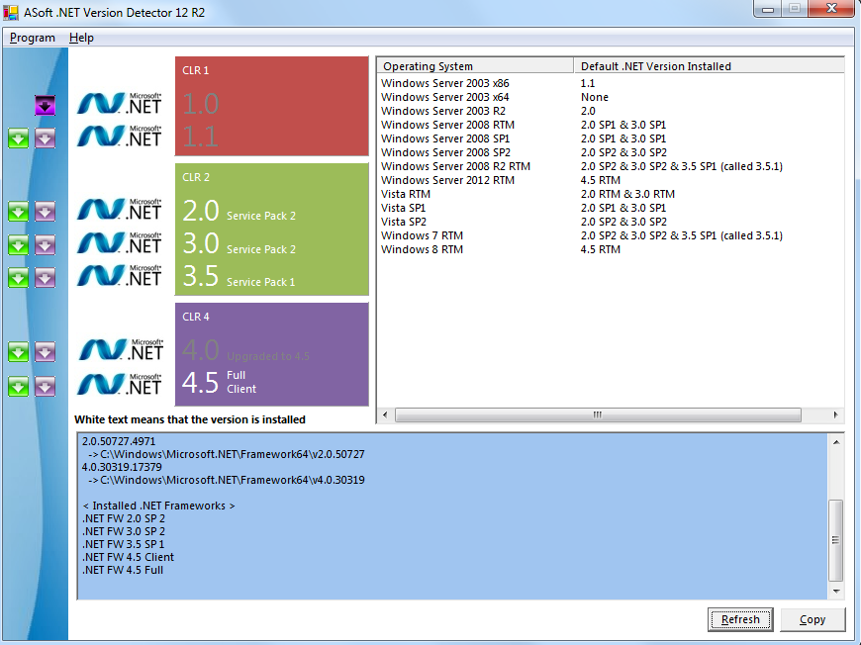

The SimpleDyno application is downloaded as a compressed .zip file from the SimpleDyno website at <https://sites.google.com/site/simpledyno>. The latest versions and updates are on the Software page. The zipped file contains the SimpleDyno.exe application and associated documentation. It also contains and Arduino Sketch to support using an Arduino Uno microcontroller to expand data acquisition capabilities (optional).

Download the zipped SimpleDyno release package file and extract the contents to any location.

**First Startup**



Double click the Simpledyno.exe icon to start the software. The first time SimpleDyno runs it will create a folder on the C:\ drive called SimpleDyno. This folder contains a settings file (SimpleDynoSettings.sds) and the basic graphical interface definition (DefaultView.sdi).

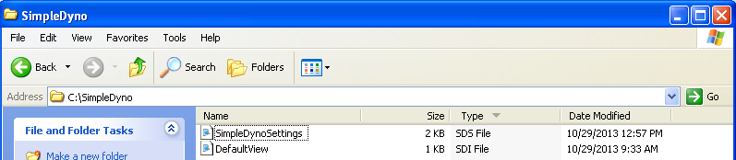

The settings file stores all the information required by the software to run such as dyno parameters, last used graphical interface, calibration curves for Arduino inputs, etc.

The DefaultView interface file stores information on the basic graphical interface (RPM gauge, actual and maximum RPM labels, and an RPM versus Time plot). This interface is created when SimpleDyno is first run. The computer’s screen settings and resolution are used to ensure that the interface fits on the screen. The graphical interface in from version 6.3 onwards is flexible to allow the creation of multiple interfaces using the building blocks provided (gauges, labels, etc.).

Previously run versions of SimpleDyno will have created the C:\SimpleDyno folder already. There is no guarantee of backward compatibility between version 6.5 (and higher) and the 5.5 version therefore existing dyno parameters may need to be re-entered. Note that once version 6.5 is run, it may not be possible to run the older versions without removing the SimpleDyno folder and allowing SimpleDyno to recreate the folder from scratch.

Once the initial setting and interface files are created, the primary application screen and DefaultView.sdi interface will display.

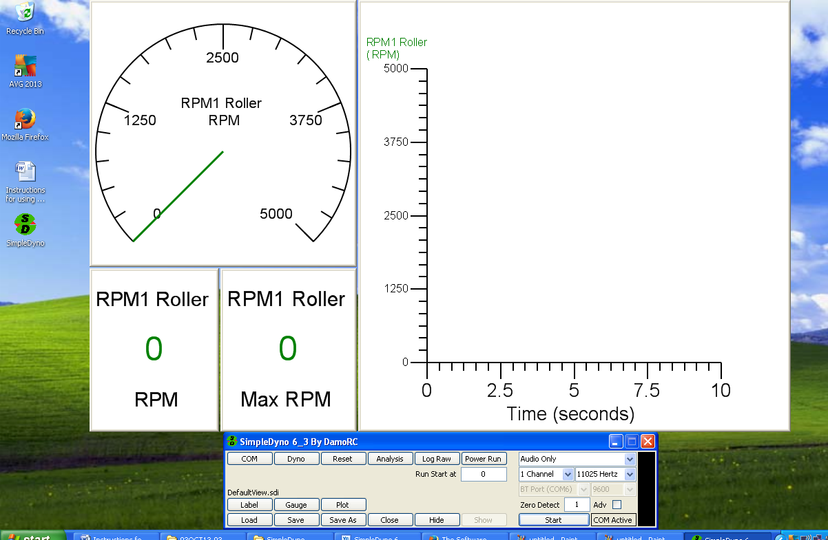

**Primary Application Screen**

The following screen capture serves as a reference for the brief descriptions that follow.

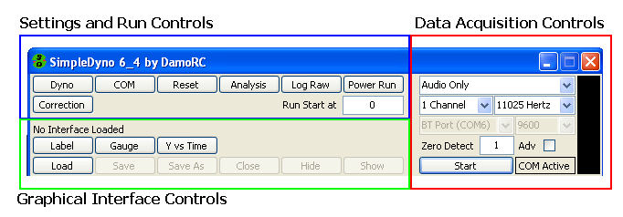

**Settings and Run Controls**

**Dyno** opens the Dyno Setup window where the parameters that define the physical characteristics of the dyno are entered.

**COM** opens the COM Port Calibration window where the parameters required to calibrate inputs received from an Arduino (or other microcontroller) are entered. **Note**: Use of the COM port to acquire data is optional. A microcontroller is not needed to use SimpleDyno 6.3.

**Reset All** resets actual and maximum data values to 0, minimum data values to 999,999.

**Analysis** loads and displays Power Run data to the Data Analysis screen. Various combinations of Power Run data can be visualized and multiple Power Runs can be overlaid.

**Log Raw** starts the process of logging data to disk. Logged data is saved as a space delimited .sdr file. These data can be imported into data analysis applications such as Microsoft Excel. The dataset cannot be further analyzed by SimpleDyno. Click on Log Raw and provide a filename for the data. The button will turn red. When SimpleDyno detects the first RPM in the dataset the button will turn green indicating that data is being collected in memory. If the maximum number of datapoints (50,000) is exceeded, the button will turn red again. When data collection is complete click on Log Raw again. SimpleDyno will write the collected data to the filename provided.

**Power Run** starts the workflow for gathering and processing RPM1 data to establish a Power Curve

**Run Start at** is the RPM at which Power Run data collection will start. Typically this is zero but some applications require the dyno to idle at a low RPM prior to initiating a run. Set this value to just above idling RPM. When RPM1 exceeds this value data collection will begin. Data collection will stop when RPM1 has dropped to this value.

**Correction** opens the dyno corrections dialog where Coast Down and atmospheric corrections can be selected and applied to the torque and power results. **Note:** Atmospheric corrections are not yet implemented.

**Graphical Interface Controls**

**Label** creates a new SimpleDyno interface component which displays data as text.

**Gauge** creates a new interface component that displays data in a gauge format

**Y vs Time** creates a new interface component that displays data as a Y versus time graph.

**Load** loads a previously saved interface. The loaded interface name is displayed. If no interface is loaded “No Interface Loaded” will be displayed.

**Save** saves the current interface, overwriting the previous interface.

**Save As** saves the current interface as a new file.

**Close** closes the current interface, removing all components.

**Hide** hides the current interface without closing it.

**Show** shows an interface that has been hidden.

**Data Acquisition Controls**

**Data Acquisition Mode**. Select a data acquisition mode. Options are Audio Only to use the mic-in jack for RPM data acquisition; Audio + COM sensing to use the mic-in jack for RPM data and an attached microcontroller to collect additional data such as Voltage, Current, etc; and COM Only to collect both RPM and additional data from an attached microcontroller.

**Audio Settings**

**Number of channels**. Select how many channels of RPM data to acquire. This applies to Audio data collection only. Select 2 Channels if to process second RPM data set (RPM2).

**Sample rate**. Select the sample rate for Audio data collection. Options are 11025, 22050, and 44100 Hz. Higher sampling rates typically produce more accurate and precise RPM data, provided the computer performance is sufficient.

**COM Port Settings**

**Port Selection**. Select the virtual COM port to which a microcontroller is attached. Ports are listed by name and number. **Note**: Do not attempt to start data acquisition using a COM option unless the required microcontroller is available and can be selected.

**Baud Rate**. Select the Baud rate for communications with an attached microcontroller. A list of commonly used Baud rates is provided. **Note**: Ensure the selected Baud rate matches that programmed on the microcontroller.

**Zero Detect and Adv settings**

**Zero Detect** sets the time SimpleDyno will wait before deciding that the roller or flywheel has stopped. If this value is set to 1 second and the dyno is configured to produce one signal for each RPM, any value less than 60 RPM (or 1 revolution per second) will be considered stopped and RPM will reset to zero. **Note**: The Zero Detect applies to both RPM1 and RPM2 data acquired either by Audio (mic-in) or by COM port. The setting is accurate for Audio RPM data. It is less accurate for the COM port data as it relies upon the data transfer rate between the computer and microcontroller. :**Note:** When using Log Raw, the Zero Detect setting determines how often data is collected if the RPM1 value times out to zero. For example, if Zero Detect is set for 1 second and RPM1 is zero, other data (RPM2, voltage, current etc) will be collected once every second. .

**Adv.** Check this box to use Advanced audio stream processing which utilizes a more sophisticated algorithm to time incoming pulses. This increases RPM1 precision significantly. Advanced analysis adds some processing overhead but is more efficient than using higher sampling rates. Adv is recommended for computers that can only support the 11025 Hz sampling rate.

**Start and Monitoring**

**Start** will initiate data acquisition based on Audio and/or COM port settings.

The **Signal** **panel** displays raw audio data and is used to set signal thresholds for pulse detection. Traces in this panel are color coded. The red trace is the raw audio data for RPM1, the primary RPM measure. This is typically the left channel of a stereo input. The green line is the threshold the red trace must exceed to be considered part of a pulse. The yellow trace is the raw audio data for RPM2. This is typically the right channel of a stereo input. The blue line is the threshold the yellow trace must exceed to be considered part of a pulse. When the mouse enters the signal panel it expands to fill the entire application window allowing more signal detail to be seen. Left click to set RPM1 threshold (green line). Right click to set RPM2 threshold (blue line).

**COM Active** indicator flashes to indicate active communication with a microcontroller.

**Using SimpleDyno**

**Dyno Setup**

SimpleDyno was written to support DIY inertia dyno projects by providing a simple way to monitor the RPM of a dyno roller or flywheel. To calculate torque and power produced, the software needs the Moment of Inertia (MOI) of the rotating parts. Using basic parameters such as roller diameter, roller mass etc., SimpleDyno will calculate the dyno MOI. MOI information produced by SimpleDyno can help in dyno design appropriate for specific vehicles and applications. Open the Dyno Setup window by clicking the Dyno button.

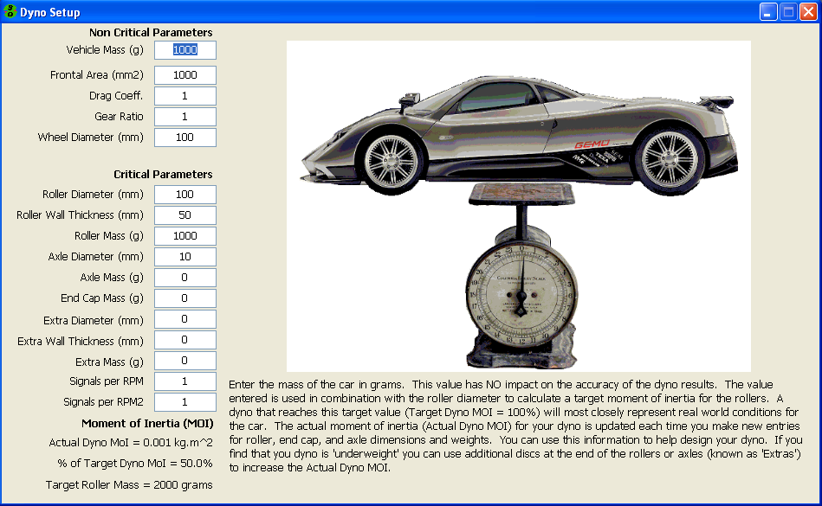

**Note**: The Dyno Setup window is designed for roller chassis dynos. However, all relevant information for a motor flywheel dyno can be entered here.

The Dyno Setup window has two data entry areas (Non Critical and Critical Parameters), an MOI display area (Moment of Inertia), a graphics area, and a descriptive text area. As each field is entered the graphics image and descriptive text will change and refer specifically to the associated parameter. The graphics and descriptive text are sufficiently detailed to guide correct parameter entry, therefore this document will not explain each parameter in detail. **Note**: SimpleDyno was initially developed for radio controlled scale vehicles and therefore all length and mass entries are in millimeter and gram units.

**Non Critical Parameters** are those that will not impact the primary results produced when running SimpleDyno, that is, they do not impact the accuracy of RPM detection and they do not impact the MOI. This means that they will have no effect on RPM1 Roller, Roller Torque and Power results. It is, however, useful provide accurate values in these fields. For example, the frontal area and drag coefficient values are used to calculate the drag a vehicle experiences at speed. A vehicle on a chassis dyno will reach speeds that exceed actual speeds on the ground. SimpleDyno calculates the drag corrected speed for a vehicle during power runs to provide a realistic value for top speed. Another example is the combination of wheel diameter and gear ratio settings. SimpleDyno calculates RPM1 Motor and Motor Torque for a chassis dyno by using the ratio of wheel diameter to roller diameter and the gear ratio. Accurate entry of these parameters ensures accurate RPM1 Motor and Motor Torque results.

**Critical Parameters** must be entered correctly and accurately for SimpleDyno to produce accurate results for RPM, torque, and power.

**Note**: For motor dynos complete the entries for Roller Diameter and Roller Mass. Also complete entries for Axle Diameter and Axle Mass depending on the dyno design. If the flywheel is attached directly to the motor set the Wheel Diameter value to the same value as Roller Diameter and set the Gear Ratio to 1. There is currently no option to display accurate Speed values if SimpleDyno is used to run a motor dyno.

**Moment of Inertia (MOI)**

As critical and non critical parameters are updated, SimpleDyno will display three results at the bottom left hand side of the window, Actual Dyno MOI, % of Target Dyno MOI, and Target Roller Mass. The Actual Dyno MOI is provided in kg.m2 or g.m2 for “light” dynos. The % Target Dyno MOI provides an indication of how close the dyno is to representing real world conditions for the vehicle information provided, specifically the mass of the vehicle. If % Target Dyno MOI is 100% the dyno will provide a real world load to the vehicle when accelerated from zero RPM. If % Target Dyno MOI is less than 100%, the dyno is “light” for the vehicle. The dyno will spool up to max RPM in a shorter period of time, and the vehicle powertrain will not experience an appropriate load. The dyno may reach maximum RPM too quickly, preventing SimpleDyno from collecting sufficient data to accurately calculate torque and power. Conversely, if % Target Dyno MOI is greater than 100%, the vehicle’s powertrain will be placed under greater stress than it would encounter on the ground, essentially simulating increased vehicle weight. SimpleDyno also calculates the Target Roller Mass to get to 100% Target Dyno MOI. This calculation takes into consideration all parameters entered for the dyno (diameter, wall thickness, etc.)

By providing you with these MOI data, the Dyno Setup screen can be used to design and build the optimal dyno for a specific vehicle.

**Note**: The % Target Dyno MOI and Target Roller Mass calculation holds true for a vehicle accelerating from rest. As the vehicle speed increases, the load on the vehicle becomes less than it would on the ground due to the missing drag component.

**Note**: The % Target Dyno MOI and Target Roller Mass values are not applicable to motor dynos using a flywheel. These values can be calculated for a motor flywheel. For help designing a flywheel for a motor dyno application please post the question to the SimpleDyno Forum.

**Audio RPM Detection**

The original SimpleDyno application introduced the concept of monitoring RPM by processing audio/electronic signal data input through the mic-in jack. This is the simplest and easiest way to monitor RPM using SimpleDyno. The original hardware consisted of a magnet attached to the dyno roller and a coil attached to the dyno frame. The coil is positioned so that the magnet passes it as the roller rotates. The coil is attached to the appropriate wires on a head set which has one of the head phones removed. The headset is plugged into the mic-in jack on a laptop computer. SimpleDyno opens an audio recording stream which monitors the signal coming into the mic-in jack. Each time the magnet passes the coil a pulse is detected by the software. By measuring the time between pulses, SimpleDyno can calculate the RPM of the roller.

A detailed description of the hardware possibilities for Audio RPM detection is beyond the scope of this document, which focuses on operating the software. Any combination of hardware that can generate a pulse when the dyno rotates will work. This section of the document will assume that the materials for the simplest type of sensor are available; a magnet on the dyno roller and a set of stereo headphones.

**“Seeing” SimpleDyno Process Audio Data and measuring RPM**

1. Plug the stereo headphones into the mic-in jack and start the SimpleDyno application.
2. Using the drop-down lists on the right hand side of the application screen select the following
   1. “Audio Only”
   2. “2 Channels”
   3. “11025 Hz”
3. Click on the start button. A red and yellow trace and green and blue threshold lines should be visible in the Audio signal monitoring panel. 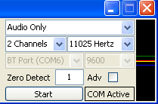
4. Move the mouse over the Audio signal monitoring panel. It should expand to fill the application window. If the mouse is moved off the expanded panel, it will contract to its original size. Keeping the mouse over the panel will keep it expanded.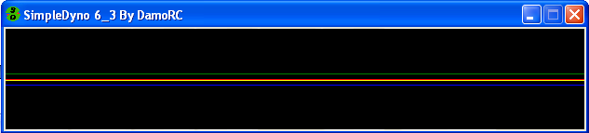
5. To pin the panel so that it stays expanded move the mouse to the very right hand edge of the panel until the mouse cursor changes to a Hand shape and left click the panel. To unpin the panel, repeat this step. **Note**: There is significantly increased processing overhead when the panel is expanded. Audio processing speed is improved with the panel at its default size.
6. Tap, blow, whistle, or speak into each of the headphones separately. Headphones behave like small microphones and therefore the red and yellow traces react to the sound. If the traces don’t react try increasing the audio recording level for the mic-in jack. With different Windows operating systems and different types of audio hardware, details as to how to increase the audio recording level are not described here. Typically, right clicking on the speaker icon that is shown at the bottom right hand side of the desktop will open utilities for adjusting this level. If the audio recording level is set to max and an audio signal is still not visible confirm that the operating system has set the default audio recording device to the mic-in or external microphone as SimpleDyno opens the recording stream on the default recording device. **Note**: If both RPM1 and RPM2 (red and yellow traces respectively) respond together regardless of which headphone is stimulated it is likely that the mic-in line is a mono only line. This means that a separate RPM2 signal cannot be monitored. 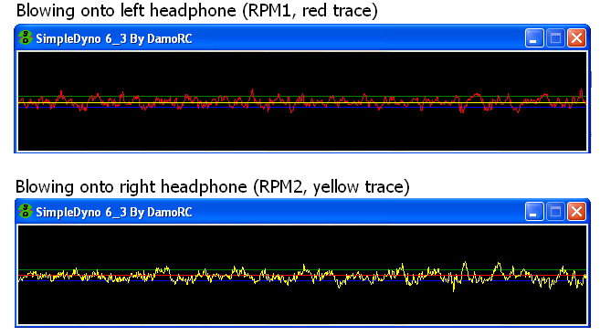
7. Confirm which headphone stimulates the RPM1 (red trace) and RPM2 (yellow trace) and label these headphones as RPM1 and RPM2. The remainder of this section will focus on RPM1 as it is the primary RPM data channel from which torque and power values are calculated.
8. Using the RPM1 headphone, try to measure the RPM of the dyno. It is assumed that a roller or flywheel dyno is available with a magnet attached. Select “1 Channel” from the appropriate drop down list and click Start. SimpleDyno will stop the current audio recording session and re-start using the newly selected options. Expand and pin the signal monitoring panel to see the raw audio signal.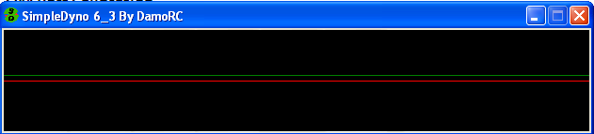
9. Mount the RPM1 headphone close to the dyno so that as the dyno turns, the magnet passes by the speaker side of the headphone. Run the dyno and watch the signal panel and RPM1 Roller gauge and graph. A first attempt may look like the following: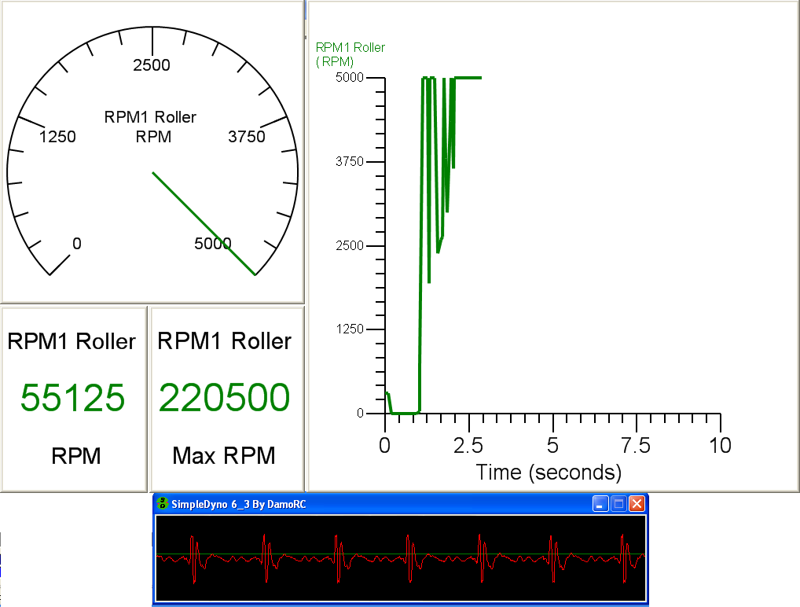

The graph of RPM1 Roller versus time shows the RPM fluctuating wildly, with a maximum RPM1 of 220,500 RPM being recorded! Although a train of pulses is observable in the signal panel, there is considerable noise in the RPM1 (red) signal trace. Examining the trace closely reveals that each pulse contains two distinct peaks. There is also a third peak between the pulses that crosses over the green threshold line.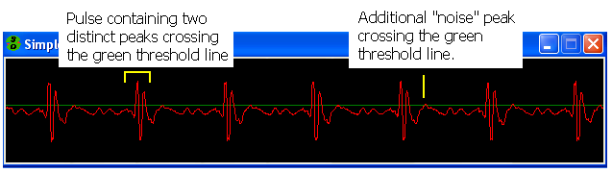Each time the RPM1 signal crosses the green threshold line, SimpleDyno measures the time since the last crossover occurred (in the same direction) and uses the time to calculate RPM. There is a short time between the two peaks within the pulse leading to a high RPM result. Then there is a gap to the next pulse leading to a lower RPM result. This fluctuating RPM1 value due to noisy raw audio data is a common problem. It should be noted that the audio signal quality and RPM fluctuation presented in this example not suitable for generating high quality data. The main reason for such a poor quality signal in this case is the headphone’s ability to act like a microphone. In addition to the magnetic pulse the headphone is picking up the noise of the motor, the dyno, and any other local sound.

1. Completely cover the speaker side of the headphone with electrical tape. This makes the headphone mostly “deaf”. By reducing significantly its ability to detect and transmit audible noise, the signal quality will be improved. A more effective method is to remove the speaker cover and fill the space with epoxy. The following screen capture was taken almost immediately after the previous one, the only difference being that the headphone was wrapped in electrical tape. The signal quality is improved leading to smooth RPM results. 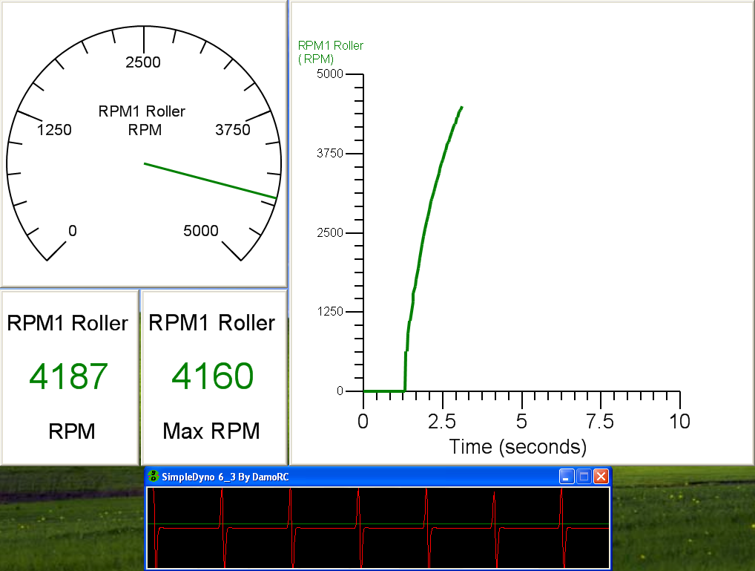
2. Even with a “deafened” headphone, there may be some low level noise in the signal that causes fluctuations in the RPM results. If these cannot be removed through hardware adjustments, set the green threshold line to a position where it continues to pick up your main peak but ignores the noise peak. Left click the signal panel to set the green threshold line. The same procedure applies to RPM2 noise. Right click the signal panel to set the blue, RPM2, threshold line. **Note**: Threshold lines can be set anywhere on the signal panel, above or below the center of the panel. Magnet/headphone combinations will produce both peak and a trough for each pass of the magnet. If the noise is a small peak, set the threshold to below the center line so that SimpleDyno uses the trough for RPM detection (and vice-versa). Generally speaking, it is best to keep the threshold line as close to the center of the signal panel as possible because the peak height decreases with lower RPM due to the slower linear speed at which the magnet passes the headphone. You can increase your peak height by positioning the magnet further away from the center of rotation of the roller or flywheel. Typically, the magnet should be placed as far away from the center of rotation as possible to produce the largest signal. Also, the audio recording level can be reduced such that the noise peak is eliminated but the pulse peak is retained. Ultimately, producing a high quality signal requires balancing the audio recording level with the threshold level which will take some experimentation. Note that the signal threshold level is less important is your are using a sensor that produces a constant voltage pulse, regardless of RPM, such as an IR sensor.
3. **Note**: The most important component in the magnet/headphone sensor system is the magnet. The smaller and stronger the magnet, the higher quality the signal. It is easier to improve signal with a better magnet than removing the headphone and replacing it with a coil.

**The Power Run.**

A Power Run is a wide open throttle (WOT) run from zero to maximum RPM in as short a time as the vehicle or motor can accomplish. This maximum acceleration run is how an inertia dyno measures peak power, the point at which the product of torque and RPM is highest. SimpleDyno can display these results live. However, even with the cleanest of audio signals and a perfectly balanced dyno, there will be some slight fluctuation in the RPM measured by SimpleDyno and this fluctuation is magnified significantly in the calculations for torque and power. To overcome this problem, the Power Run function collects the data during the run and subjects it to a curve fitting operation which smoothes out these slight fluctuations, producing smoothed torque and power curves. To execute a power run:

1. Ensure that sensor hardware is connected and that high quality RPM1 Roller data is being produced.
2. Click the Power Run button.
3. Provide a filename for the run which will be saved as a space delimited text file with an .sdp extension. **Note:** The Power Run button will turn red once a filename has been provided. It will turn green when the minimum number of points (10) has been collected. If the maximum number of points (50,000) is exceeded it will turn red again.. 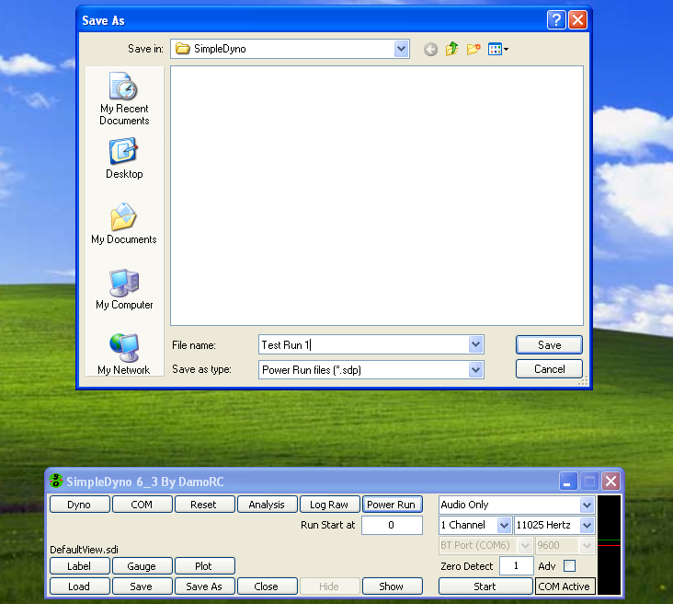
4. Wide open throttle the vehicle or motor until to maximum RPM. Then allow the dyno to coast to a stop (or use a brake if the dyno is fitted with one).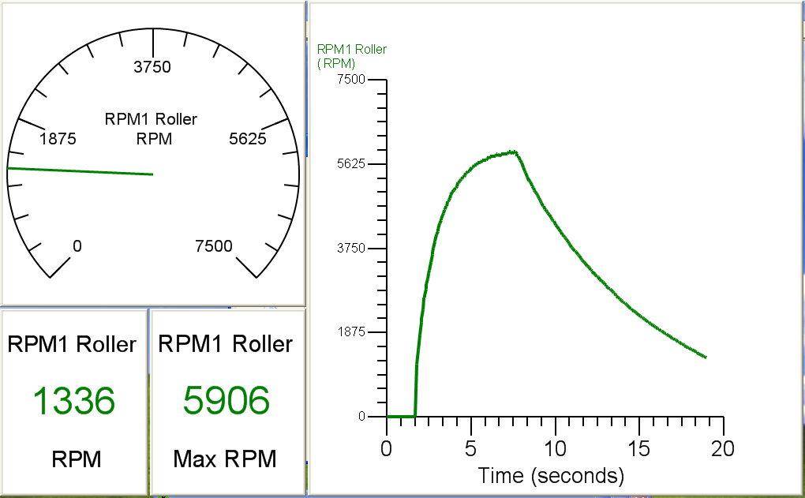
5. When the dyno is stopped the curve fitting process will start. SimpleDyno will open the Curve Fitting window. The first time SimpleDyno is run the default curve fit model selected will be the 2rd Order Poly (polynomial) model. **Note:** Depending on the processing speed of your computer, the size of the data set, and how well it fits the selected model the amount of time taken to complete the curve fit can vary from a few seconds up to a minute. A progress bar indicates that the software is processing the data.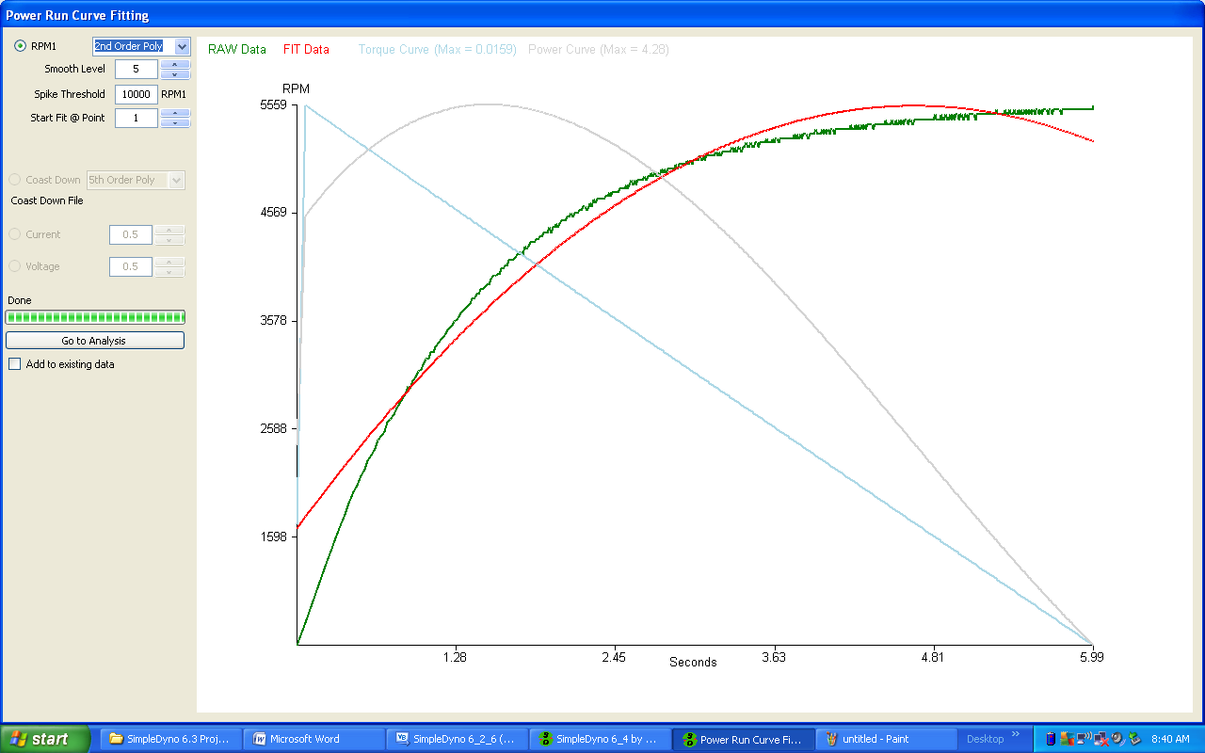
6. The goal in the Power Run Curve Fitting window is to find a curve fit that closely models the data. The green trace is raw RPM data. The red trace is the curve fit model produced by SimpleDyno. Additional traces are provided to show what the torque (pale blue) and power (pale gray) curves will look like in the final analysis and the maximum torque and power results for the current fit are presented at the top of the window in N.m and Watts respectively. **Note:** the addition of the torque and power traces is to allow examination of the shape of these curves and not to maximize torque or power results. These traces are particularly useful when using the MA smooth fitting model. In the previous figure, the 2rd Order Poly model does not fit the data well, that is, the green (raw data) and red (fitted data) do not overlay well. This example run is a small brushed electric motor dyno and therefore the Four Parameter model fits the data well. Select various models from the drop down list until the optimal curve fit is found. **Note**: Once the optimal model is found, the same model should apply to subsequent Power Runs. There is typically no need to test all of the models for each run. The same raw data is presented in the next figure using the Four Parameter fit model. The raw and fit curves are almost perfectly overlaid making this a good fit. 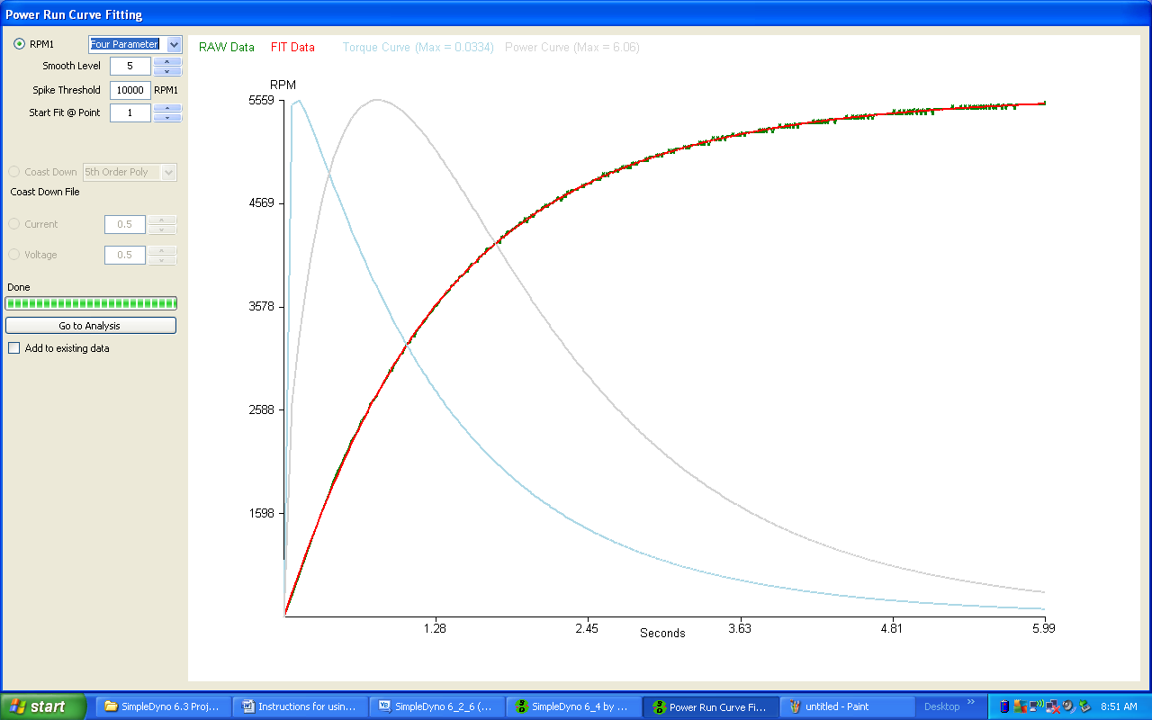
7. Occasionally, a curve fit that should work well with the data set, does not produce a satisfactory fit. This can be due to problems with the first few data points in the raw data set. The software can be directed to refit the data skipping the initial data points by changing the Start Fit @ Point field.
8. If the raw data set suffered from a spike during the run, SimpleDyno will remove the spike based in the value entered for Spike Threshold. Any data point that differs from its neighboring data points by this amount will be considered a spike and be removed from the curve fit. **Note:** Care should be taken in setting this value. Setting the value too low has the potential to remove key data points from the beginning of the run. **Note:** The spike threshold value is also applied to spike removal from the Coast Down data set.
9. **Using the MA Smooth Fitting Option.** Some engine and dyno setups will produce data that is not easily constrained to a mathematical model. Typically larger internal combustion engines fall into this category. Rather than use a poorly fitting mathematical model, SimpleDyno offers a smoothing option. The option currently available (Version 6.4) is a moving average smoothing process. The following example data is courtesy of **Makr (a.k.a. Mark)** and was generated on a motor flywheel dyno by a motorbike engine developing approximately 100 HP. 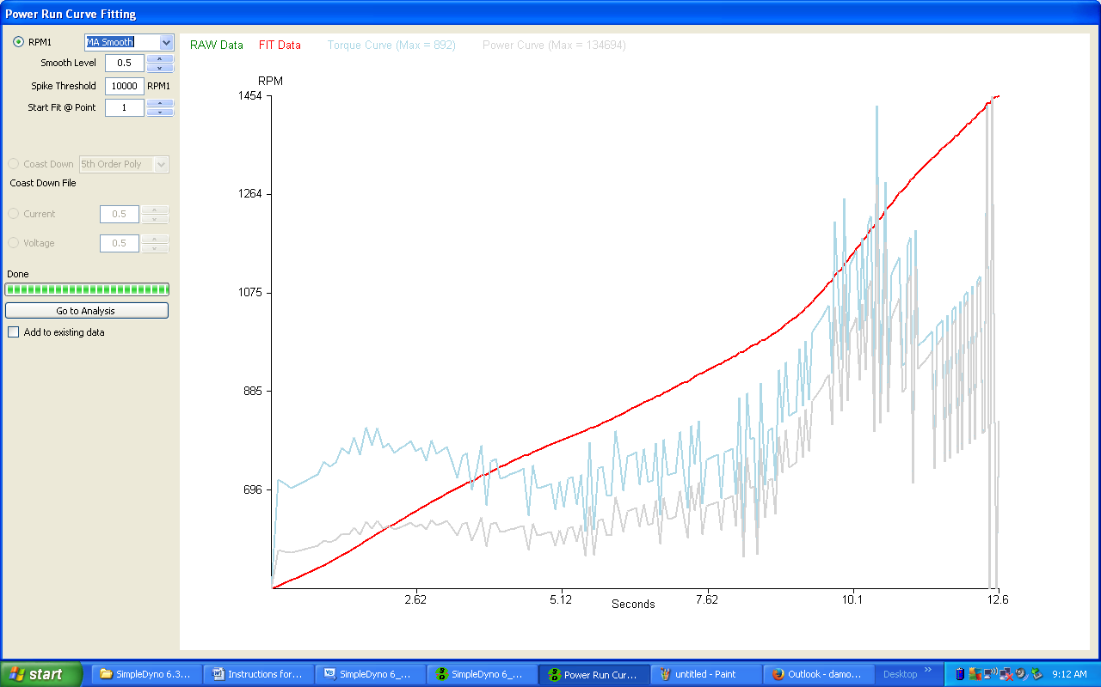
10. In the figure above the data was smoothed using the lowest smoothing level of 0.5. This will typically produce power and torque curves that are almost identical to using the raw data and therefore will be extremely noisy and unusable. Note that the red fit trace perfectly overlays the green raw data trace so that it is difficult to see the raw data. Increasing the smoothing level to 1.0 produces the following result. 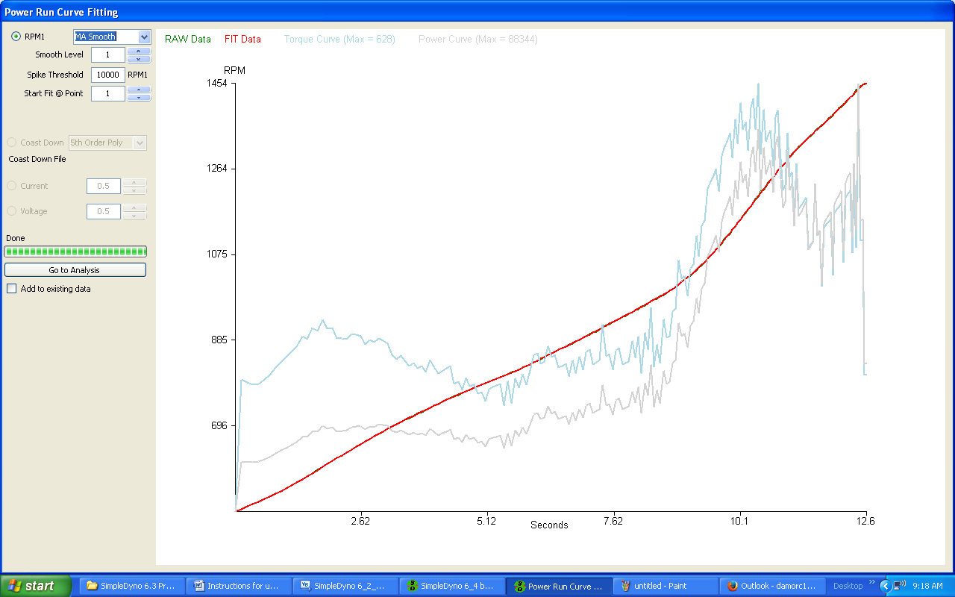Although the power and torque curves are still noisy, the bigger picture of torque and power development is somewhat clearer. Note that the raw and fit data traces are still perfectly overlayed. Increasing the smoothing level to 5.0 produces the following result. 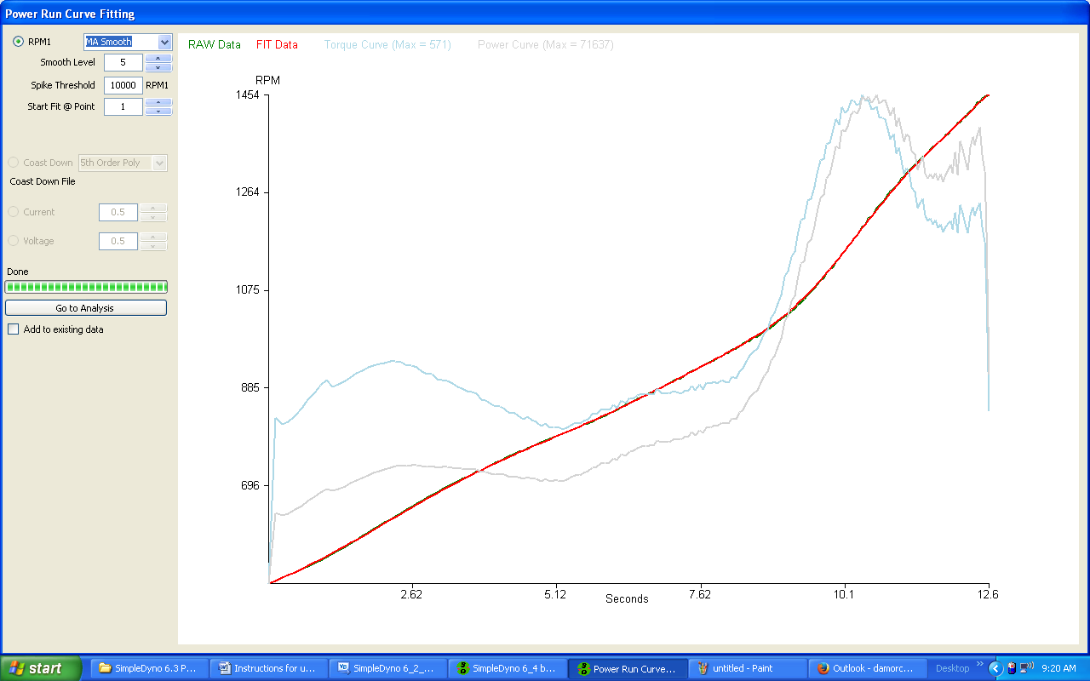Now the data look reasonable for use. There are some minor deviations between the raw and fit data but overall the fit is good and the power and torque curves are appropriately smoothed. If the data processed further using a smoothing level of 10.0 the following results are observed.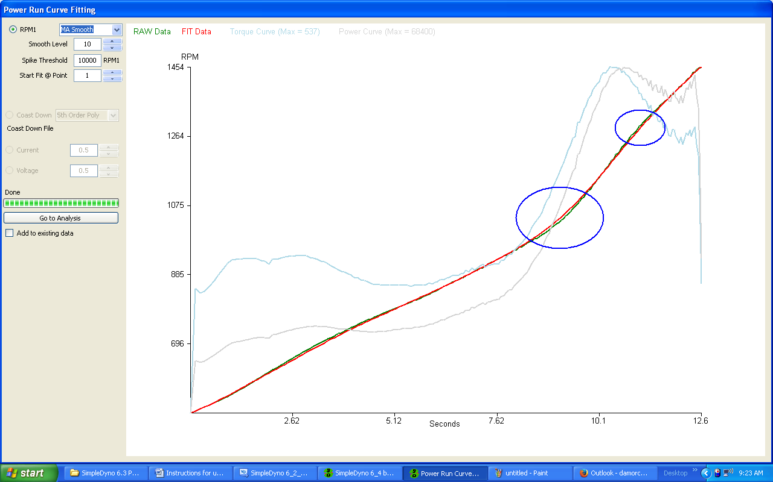Although the power and torque curves still look good, there are gaps appearing between the raw and fit data sets as indicated by the blue ovals. This indicates that the smoothing level is too high and should be scaled back. Using the MA Smooth fit model is a balance between smoothest possible power and torque curves with little or no deviation between the raw and fit data, particularly around areas of interest such as peak power or torque. Returning the smoothing level to 5.0 and examining the data in the Analysis screen shows that this smoothing level is appropriate for these data. 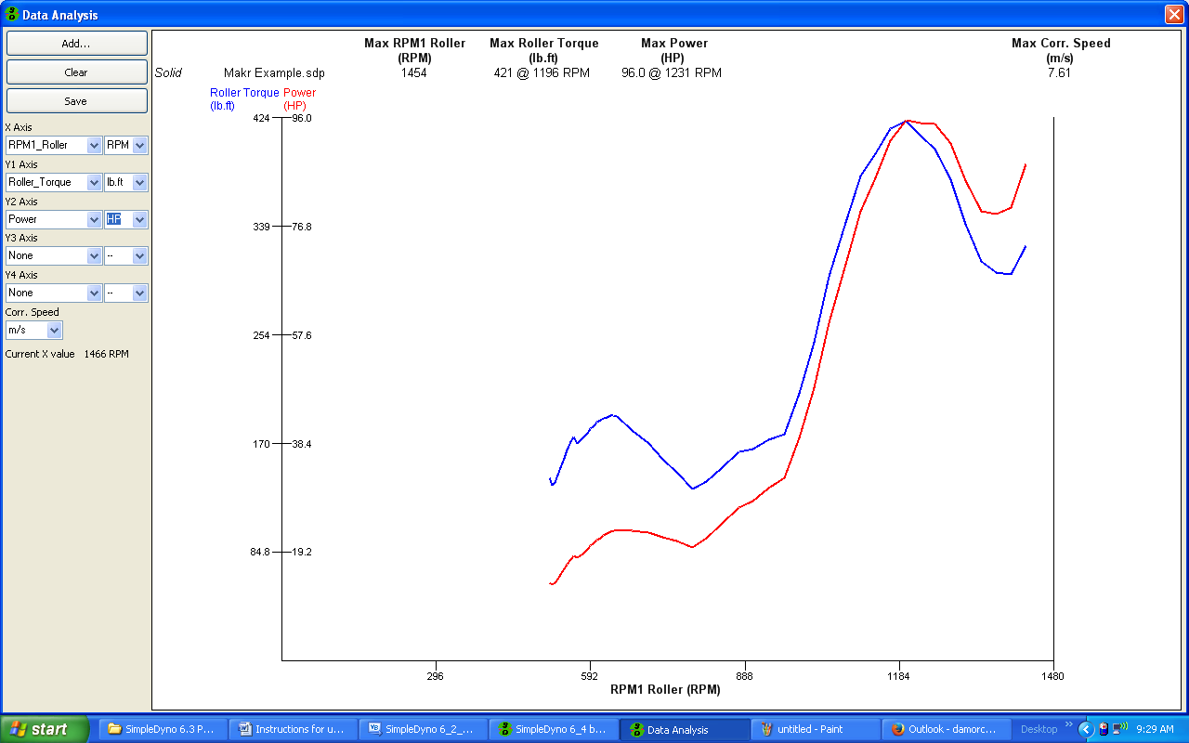
11. Once the optimal model is found, click the Go to Analysis button. The first time the Data Analysis window loads, all of the axes will be set to “Time”. 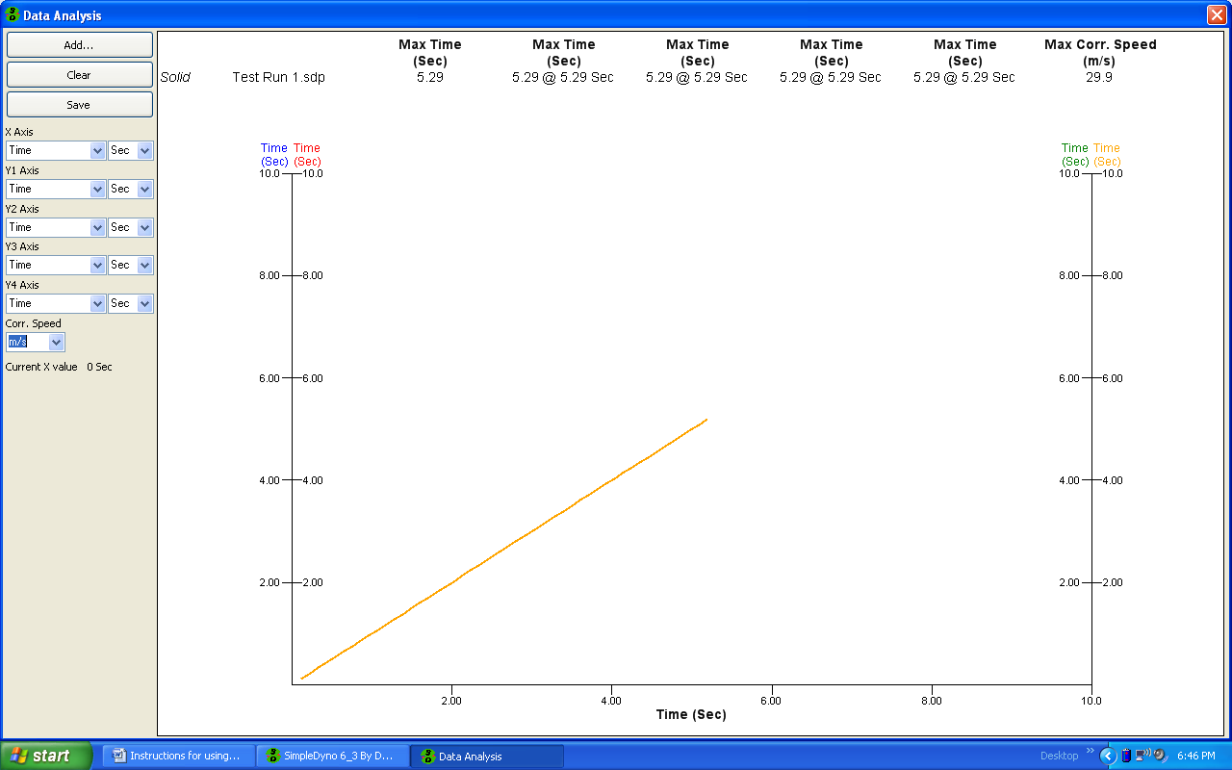
12. Typically, power runs are plotted against RPM. Select the following options from the described drop down lists.
    1. X Axis : RPM1 Roller (also select RPM units)
    2. Y1 Axis: Roller Torque
    3. Y2 Axis: Power
    4. Y3 Axis: Speed (also select MPH units)
    5. Y4 Axis: None
    6. Corr. Speed: MPH
13. The Data Analysis window displays the data so that torque and power curves are clear. Maximum results are shown at the top of the screen. To see data for a specific part of the run click on the graph at that point. To see maximum results again, click on the graph outside of the area contained by the axes. **Note**: The presented Corr. Speed results are the maximum speed the vehicle would have reached if power losses due to drag were considered. 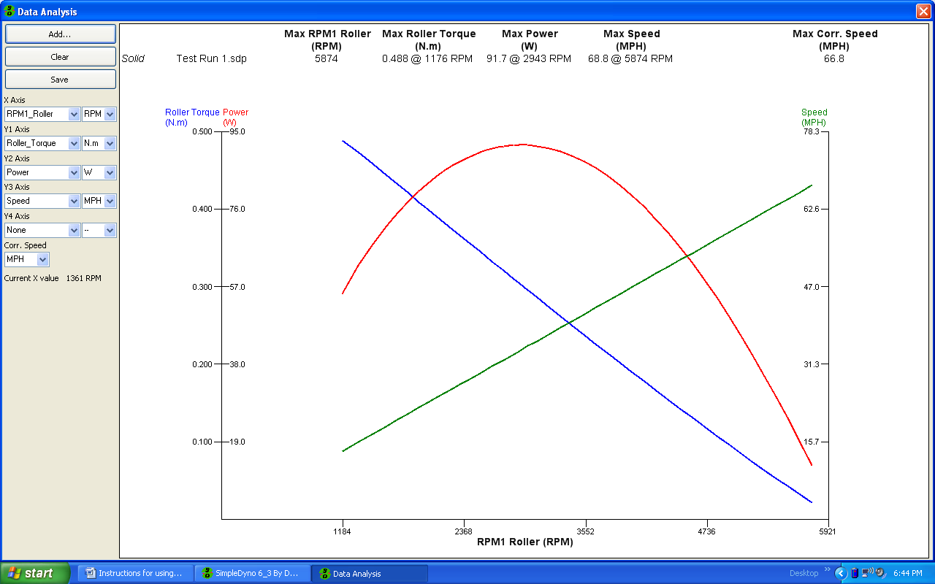
14. To cancel a Power Run after providing a file name, click the Power Run button again. If SimpleDyno has already moved onto the curve fitting screen, click on the Stop Fitting button to stop the curve fitting process.
15. Use the Spike Threshold setting in the Power Run Curve Fitting screen to filter out occasional spikes. **Note**: The Spike threshold should only be used if one or two large spikes appear in the Power Run raw data.
16. The fit can sometimes benefit from skipping the first few points of raw data. This is achieved using the “Start Fit at Point” field. This is typically not needed.
17. If Voltage and Current data was recorded during the power run these data can be selected for smoothing. Modify the smoothing level required using the up/down arrows.

**Dyno Corrections**

SimpleDyno 6.4 introduces a Coast Down correction feature for adjusting torque and power results based on dyno or drivetrain losses.. The coast down RPM data of the dyno are subjected to a curve fitting algorithm and the Coast Down Torque and Power results are generated. These results are then used to modify (typically increase) the Power Run torque and power results. To setup this feature, click the Correction button on the primary application screen. To use coast down correction, first check the Use Coast Down checkbox. Then select the type of coast down configuration you are going to use. There are three options available, Free Roller, Roller + Wheel, and Roller + Drivetrain. The type of configuration you choose controls how the coast down corrections are applied.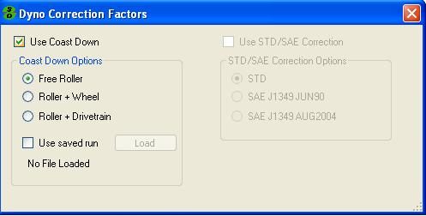

**Free Roller** is appropriate for those dyno configurations where all motor and drivetrain components can be physically disengaged from the roller or flywheel once maximum RPM is reached. An example is an RC chassis dyno where the vehicle can be physically lifted off the rollers when the Power Run maximum RPM is reached. The coast down torque and power data represent the parasitic losses of the roller or flywheel only. These losses are added back to the roller torque and power results and, subsequently, used to adjust wheel and motor torque and power. **Therefore Corrected Roller, Corrected Wheel and Corrected Motor results for Torque and Power are all adjusted.**

**Roller + Wheel** is appropriate for those dyno configurations where the motor and drivetrain can be disengaged from the vehicle wheels at maximum RPM so that the losses now represent those created by wheel contact with the roller and the rollers own losses. An example of this configuration would be a bike dyno where the wheel has a freewheel capability. The losses are added back to the wheel torque and power results and subsequently used to adjust motor torque and power. **Therefore Corrected Wheel and Corrected Motor results for Torque and Power are adjusted. Corrected Roller results are not adjusted.**

**Roller + Drivetrain** is appropriate for those dyno configurations where the motor can be disengaged from the drivetrain, wheel and roller at maximum RPM so that the losses represent those of the entire system except for the motor. An example of this type of configuration is any vehicle chassis dyno where the motor can be disengaged with a conventional clutch. The losses are added back to the motor torque and power results only. **Therefore, Corrected Motor results are adjusted. Corrected Roller and Corrected Wheel results are not adjusted.**

**Note: The Free Roller coast down feature is the most justifiable loss correction configuration that can be used. Although the Roller + Wheel and Roller + Drivetrain loss adjustments are available, the user should think carefully about the impact of these corrections on true Torque and Power results.**

Once the “Use Coast Down” feature is selected and the type of run down model is chosen, this correction applies to all Power Runs performed in a session. If SimpleDyno is closed and re-started, the Correction information must be re-entered for the new session.

The Coast Down data must be processed using curve fitting or smoothing algorithms in the same way that the Power Run acceleration data is handled. If Use Coast Down is selected, an additional curve fitting operation will be performed by the software on the deceleration phase of the run. Using the electric motor data previously presented and having selected the Free Roller option, the curve fitting screen will look as follows. 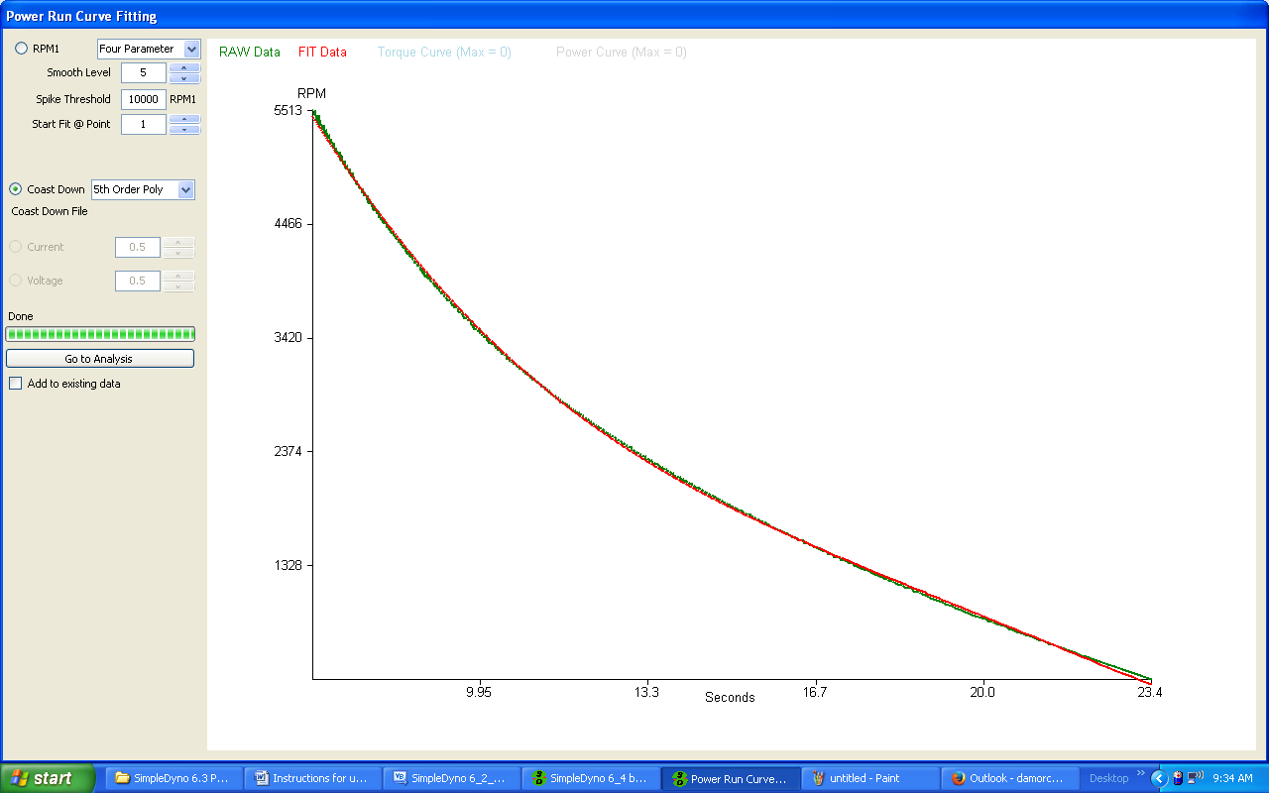

The Coast Down was fitted using the 5th Order Poly fit in this example. Moving to the Analysis screen and selecting Coast Down Torque and Coast Down Power for display looks as follows.

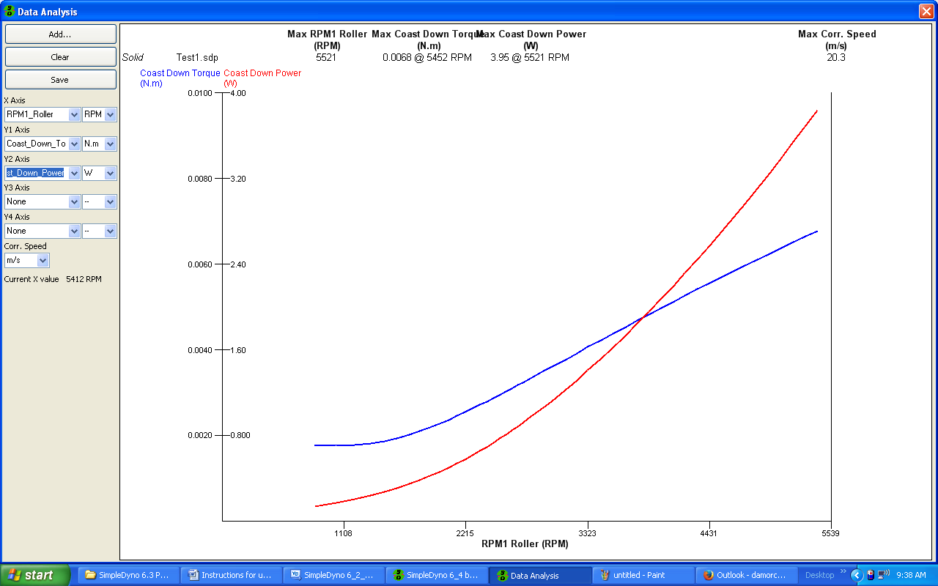These are torque and power losses over the RPM range. These losses are used to correct torque and power results for the roller, wheel, and motor as described earlier (depending on the Coast Down option selected). For example, these are the results from this run when the Power and Corrected Roller Power are plotted in the Analysis screen. 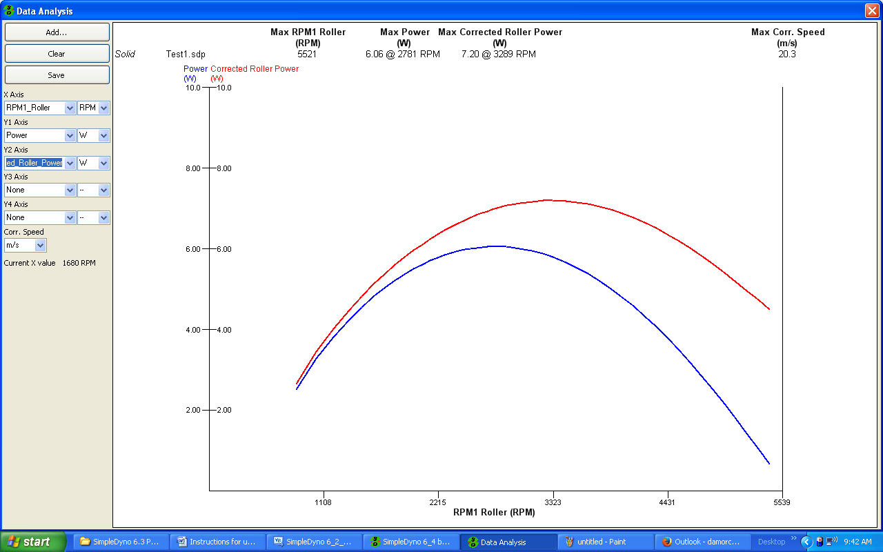

**Using a Saved Run for Correction**

You can use the coast down data from a previous run to adjust all Power Runs in a single session. For example, if you have already created a Free Roller run down data set for your dyno, you can apply this data set to all subsequent power runs if needed. To use a previously saved Power Run for correction, simply check the “Use saved run” checkbox and click on Load to load the previously saved coast down data. **Note:** If the file selected was not processed for coast down data it cannot be used. Also, the way in which the coast down data was used in the saved file will be applied. For example, if the loaded file was processed using the Free Roller option for coast down correction, the coast down losses contained in the file can only be applied as Free Roller corrections.

**Data Analysis**

The Data Analysis window is used to examine Power Run files. It can be also used to overlay multiple files to compare different runs. The Data Analysis window appears automatically as part of the Power Run workflow. It can also be opened by clicking the Analysis button on the primary application screen. Currently a maximum of five files can be overlaid. Use Add… to add files, Clear to remove all files and Save to save and image of the overlaid results. SimpleDyno distinguishes individual runs graphically by using solid, dashed and dotted lines. **Note**: All available SimpleDyno parameters are available for plotting in the Data Analysis window. However, if a parameter is selected for which no data was collected during the run (for example, Voltage data during Power Run that used Audio Only as the data acquisition mode), it will be displayed as a flat line of zero values. **Note:** SimpleDyno 6.3 offers backwards compatibility with version 5.5 power run files.

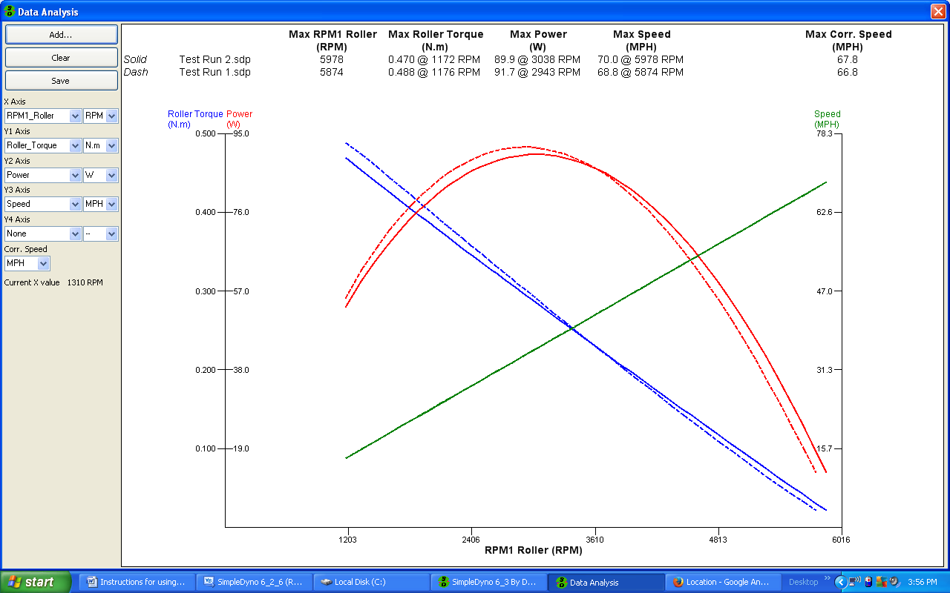

**The Graphical Interface**

SimpleDyno 6.3 introduces a new graphical interface for viewing live data. The interface approach is more flexible than the old fixed window layout and allows viewing of as many or as few parameters as needed in a number of different formats. Each interface component can be moved and resized and color and font options are available.

A SimpleDyno interface is built using interface components. In version 6.3 the available components are Label, Gauge and Y vs Time. When first run, SimpleDyno creates a DefaultView interface comprising of two vertical Labels, a 270 degree Gauge and a Y vs Time with RPM1 Roller selected as the only Y Axis.

The buttons Load, Save, Save As, and Close apply to all of the components as a group and their functions do not require detailed explanation. Hide and Show also apply to the components as a group. All components created by SimpleDyno are coded to be on top of everything else on the desktop. Switching from SimpleDyno to another application will cause the primary application screen to move to the background but the interface components will not. They will insist on being visible at all times. Use the Hide and Show buttons to control the visibility of the interface.

All of the interface components share a number of common characteristics which are as follows:

1. To move a component, click the component anywhere inside its frame and drag the component to the new position.
2. To resize a component, click and drag its frame as with any Windows form. **Note**: When moving or resizing a component, a snap-to-grid type function is used to help keep sizes uniform and layout aligned.
3. To remove a component from the interface, double click the component anywhere inside its frame. **Note**: Components cannot be hidden individually. Double clicking a component permanently removes it from the interface being displayed. However this change is not written to file unless the interface is saved using Save or Save As.
4. To assign a value or to configure a component, right click anywhere inside the component and the component menu will be displayed.

The Label component will be used to demonstrate how to use the new graphical interface.

**The Label**

The Label component displays the selected parameter value as text.

1. Start SimpleDyno. The DefaultView interface will load. Click the Close button to close the interface.
2. Click the Label button to create a new Label.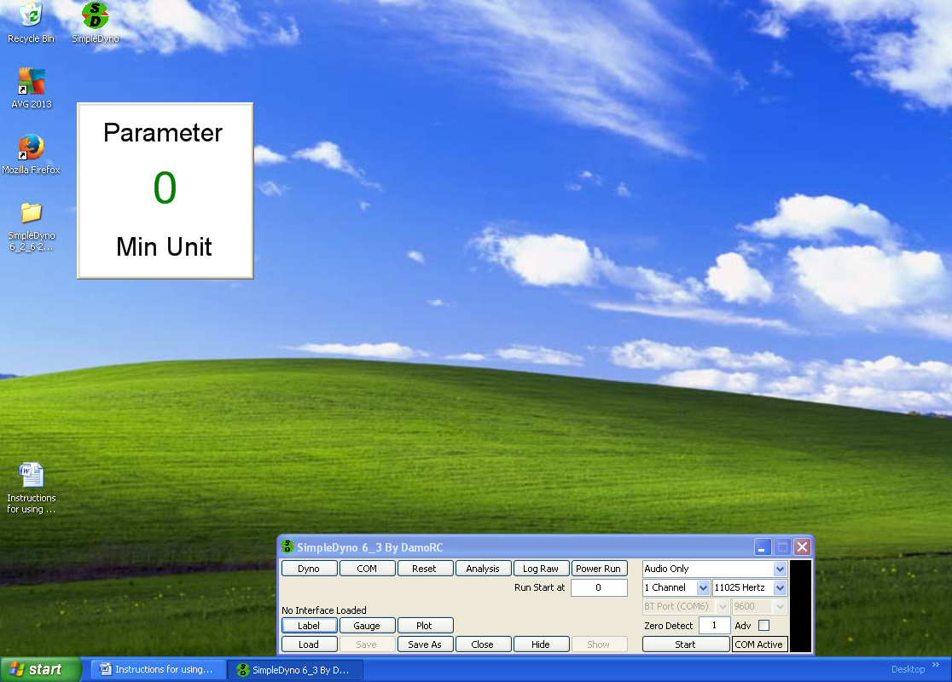
3. Right click inside the Label frame to open the component menu. The component menu is divided into two sections. The upper section lists all of the parameters that SimpleDyno makes available for display. The lower section lists component specific options and formatting functions. 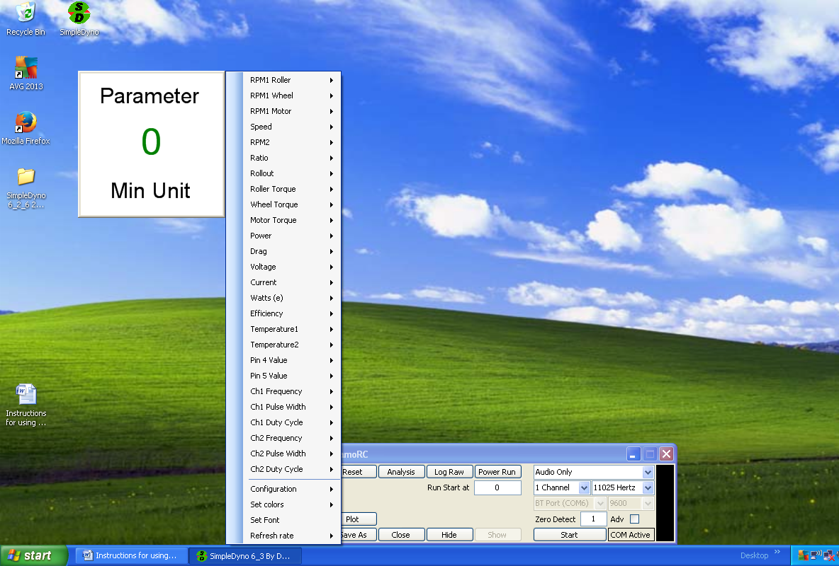
4. **Note**: If data acquisition has not been started, the component menu will list all possible parameters available for display. Once data acquisition is started, the component menu will limit the available parameters to those appropriate for the data acquisition setup. For example, using 1 Channel, Audio only data acquisition will produce the following truncated component menu. 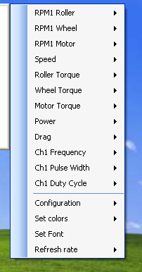
5. Configure the Label to display the current RPM1 Roller data in units of RPM. As RPM1 Roller is selected, a sub menu item for Minimum, Actual, or Maximum will appear. As Actual is selected (for the live value) another sub menu item listing the units rads/s and RPM will appear. Select the RPM option. **Note**: All of the component menu items operate in this fashion, that is, follow a path of sub menu items to its final destination to complete the operation.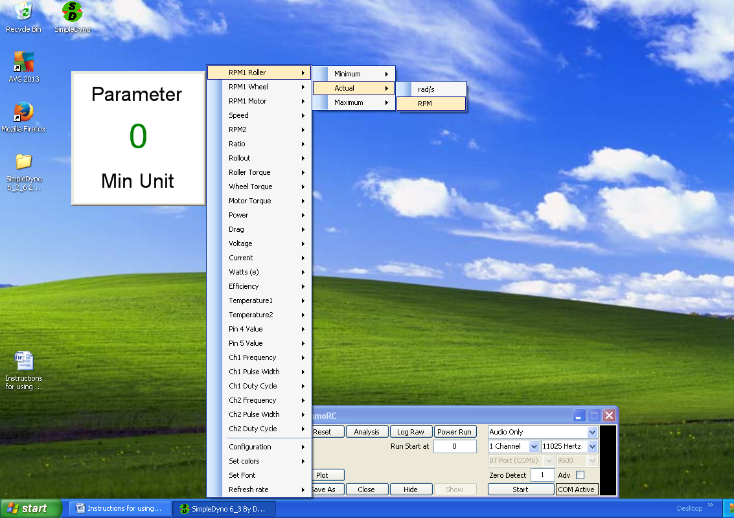
6. The label is now connected to a data parameter. Once the data parameter is selected, the component is active and will be monitoring and displaying the appropriate data.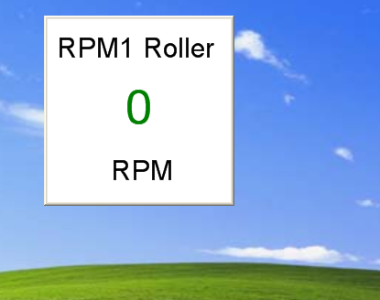
7. **Note**: For Actual (live) data, only the unit name is displayed. For Minimum and Maximum data, the unit is prefixed with Min and Max respectively. Here are three labels for Minimum, Actual and Maximum RPM1 Roller data.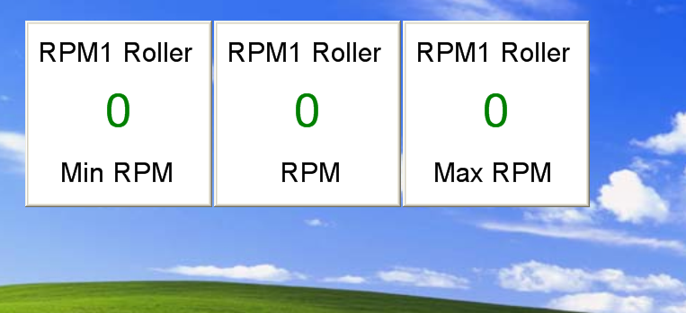
8. **Configuration**. Each component has its own specific configuration. In the case of the Label component these are Vertical and Horizontal, which adjust how the parameter name and units are displayed relative to the data value.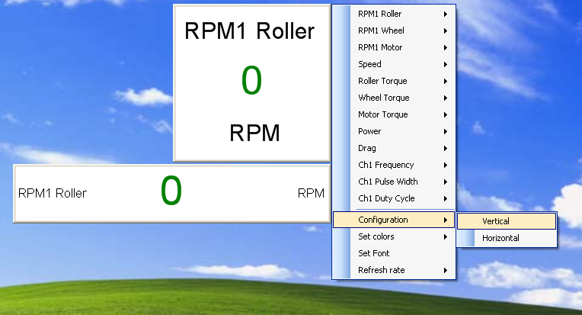
9. **Set Colors**. Each component has a Set Colors option which is common to all components. This allows the selection of colors for various parts of the component. The available options are Background, Axes, Data, and Apply to All. When Background, Axes, or Data are selected SimpleDyno opens a color selection dialog for color selection. When Apply to All is selected, the colors for that component are applied to all other visible components. For the Label control, setting the Axes color sets the color used to write the parameter name and units. 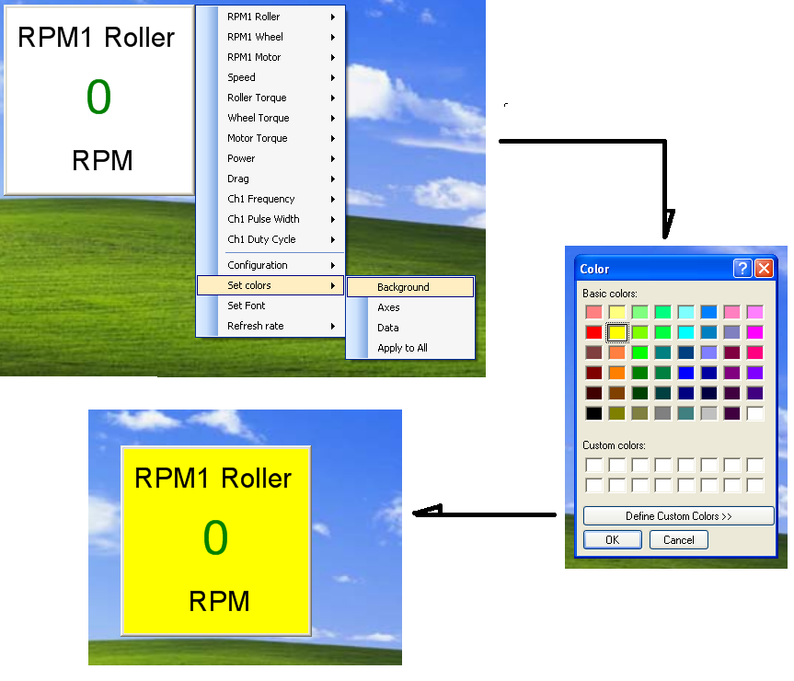
10. **Set Font.** Each component has a Set Font option which will open a Font dialog. The font selection applies to all of the text displayed in the component. **Note**: Although all available fonts are presented for selection, some fonts do not meet certain software requirements to allow SimpleDyno to use them. If these are selected, SimpleDyno will revert to the previously used font. **Note**: The font selection process ignores any selections for bold, italic, etc. It also ignores any font size selections made as these are calculated by SimpleDyno to ensure all text fits appropriately on the component.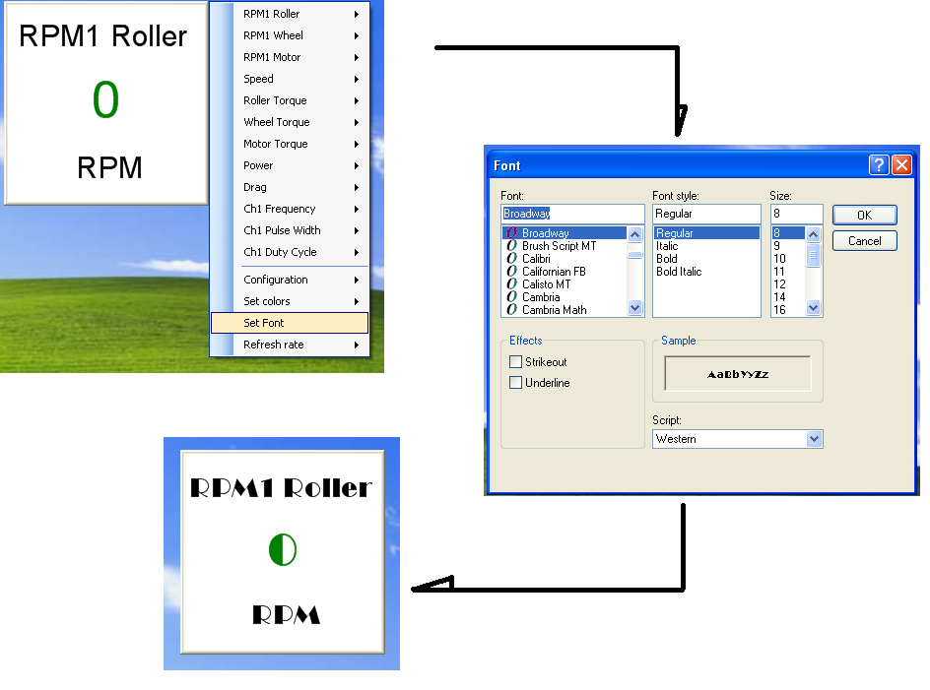
11. **Refresh Rate.** Each component has a setting for Refresh Rate which sets the component’s internal timer controlling the interval between each call to SimpleDyno for new data. The default time is 1000 miliseconds (ms) which is 1 second. This is appropriate for a Label component as the data in the component need to be read. For graphical representation of data such as the Gauge and Y vs Time components, a higher Refresh Rate may be appropriate for smooth operation. **Note**: Higher refresh rates requires the computer to work harder to update the components. Using more components with higher refresh rates can impact SimpleDyno’s performance, most notably in processing high sample rate Audio data.

**The Gauge**

The Gauge component provides a gauge representation of data. The previously described functionality of the Label component applies also to the Gauge component. The configurations available in 6.3 and 6.4 versions for the Gauge component are 90, 180 and 270 degree dials, all upward pointing. Version 6.5 introduces a totally configurable gauge allowing the gauge arc width (degrees) and point direction (degrees) to be set. Version 6.5 also allows the sweep direction of the gauge to be clockwise or anticlockwise.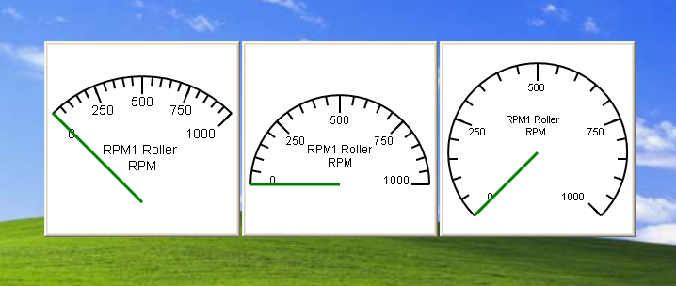

The Gauge component also has a Range option which is used to set the Minimum and Maximum display values for the Gauge. Follow the sub menu items under Range to the text box and enter the value for Minimum or Maximum. You MUST press Enter after inputting the new value to apply it to the component.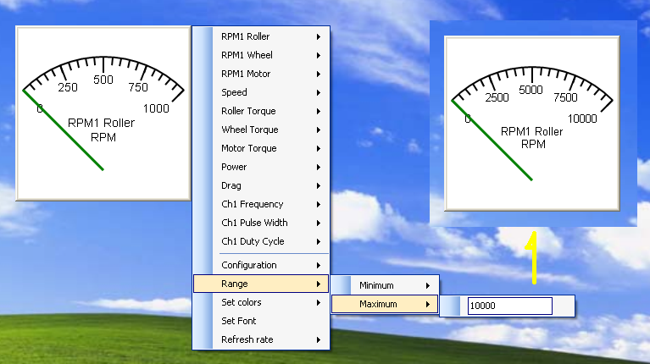

**The Y vs Time Component**

The Y vs Time component graphs selected parameter(s) on the Y axes against Time (seconds) on the X-Axis. All of the previously described functionality is available with the Y vs Time component. The configuration options for the Y vs Time component are Lines and Points where data will be displayed as joined lines or separated points respectively. Each axis also has Minimum and Maximum Range options

The default Y vs Time component displays a single Y parameter versus Time. Up to four different parameters can be dilsplayed on the one Y vs Time component. Additional parameters can be added to the plot by right clicking the component. Use the following as a reference to add, remove, or configure additional axes/parameters. Minimum and Maximum Range values for the X Axis can be set from any visible component menu. 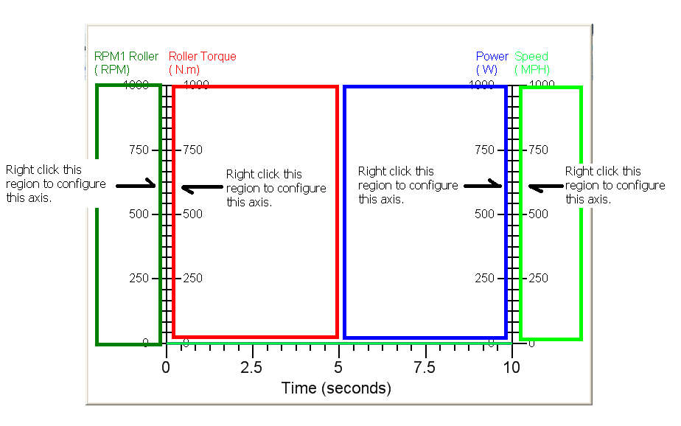

**Using a Microcontroller with SimpleDyno**

A microcontroller can be used with SimpleDyno to add data acquisition functionality. This functionality was developed with the Arduino Uno platform but any microcontroller that can perform serial communication through a virtual COM port can be used. The Arduino was chosen for development due to its ease of use both from a hardware and firmware / software standpoint. If a different microcontroller is to be used, see the end of the section for the communication requirements. The rest of this section will refer generally to the Uno platform.

**Preparing the Arduino Uno for use with SimpleDyno**

For any microcontroller to be used with SimpleDyno, it must be programmed. A description of how to program the Arduino Uno is beyond the scope of this document. However, there is an enormous amount of information available for using this platform. The first place to visit is the Arduino website at [www.arduino.cc](http://www.arduino.cc). The software required to program your Uno can be downloaded from this site. This software creates programs known as Sketch files which are uploaded to the microcontroller. The Sketch file required to program an Arduino to work with SimpleDyno is included in the SimpleDyno zipped file (SD6_3 Sketch.ino). Follow the instructions at the Arduino website for compiling and uploading this Sketch file to the microcontroller.

There is only one line of code in the Sketch that requires attention, the Baud rate at which the microcontroller communicates with the computer. The default setting is 9600 Baud, both in the Sketch file and in SimpleDyno. To use a higher data transfer rate by selecting this rate from the appropriate drop down menu in SimpleDyno, the same rate must be defined in the Sketch file. Then re-compile the Sketch and upload it to the Arduino before SimpleDynois started.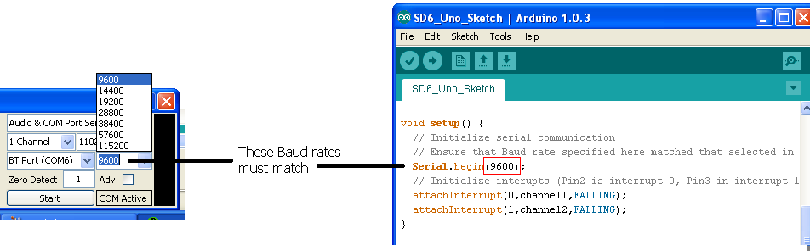

Once the SD6_3 Sketch file is uploaded to the Arduino it is ready to gather data and transfer data to SimpleDyno.

SimpleDyno offers two options for using a microcontroller to acquire data. Audio & COM Port Sensing allows the use of the mic-in line to gather RPM1 and RPM2 data while also reading additional sensor data from the microcontroller. In COM Port Only mode, the microcontroller will read the RPM1 and RPM2 values as well as reading the additional sensor data. For this discussion we will only describe use of the Audio and COM Port Sensing because , from a SimpleDyno software perspective, handling of RPM1 and RPM2 data from the microcontroller is identical to handling RPM1 and RPM2 data from the Audio stream (without having to deal with an audio signal).

SimpleDyno will process 6 analog data streams supplied to it from the microcontroller. These are Voltage, Current, Temperature 1, Temperature 2, Pin 4 Value, and Pin 5 Value. These data are collected from the Arduino Analog In pins A0 – A5 respectively.

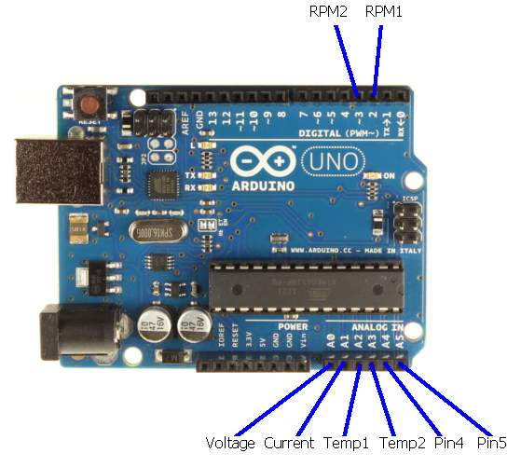

The design and use of individual sensors / circuits is beyond the scope of this document. However, to demonstrate how the COM Port communications and calibrations are used, the Voltage for a 2S Lipo battery with a measured voltage of 8.29V is discussed.

**Note**: CHECK the maximum voltage inputs that the microcontroller can handle before attempting to connect any sensors otherwise damage to the pin or entire microcontroller may occur. In the case of the Arduino Uno, 5V is the maximum voltage to apply to the Analog In pins. If a battery other than a 2S Lipo is chosen for this exercise, the voltage delivered to Pins A0 and A1 must not exceed 5V.

**Calibrating COM Port Data**

To allow SimpleDyno measure the voltage of a battery which is greater than the allowed Pin A0 voltage of 5V a voltage divider must be used. Construct the voltage divider using two resistors in series. Connect the battery across the resistors and connect the junction between the resistors to the A0 pin. Connect the battery ground or negative terminal to the GND pin on the Arduino. The voltage at pin A0 will be approximately half of the battery voltage depending on the tolerances of the resistors used in the voltage divider. 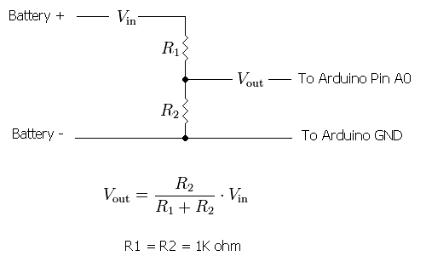

Start SimpleDyno. Select Audio & COM Port Sensing as the data acquisition mode and click the Start button. The COM Active label will flash indicating that communication with the Arduino is working. Close any open graphical interface and create a new Label component. Select Voltage as the parameter to monitor. 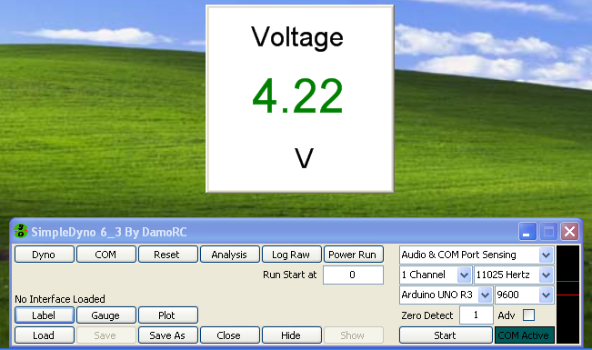

SimpleDyno is reporting a battery voltage of 4.22 volts. Technically this is correct as this is the voltage being applied to Pin A0. However the actual voltage of our battery is 8.29V. For SimpleDyno to report the battery voltage accurately, a calibration curve for the Voltage parameter being measured at Pin A0 is required.

To provide SimpleDyno with the necessary values for calibration, click on the COM button to open the COM Port Calibration window.

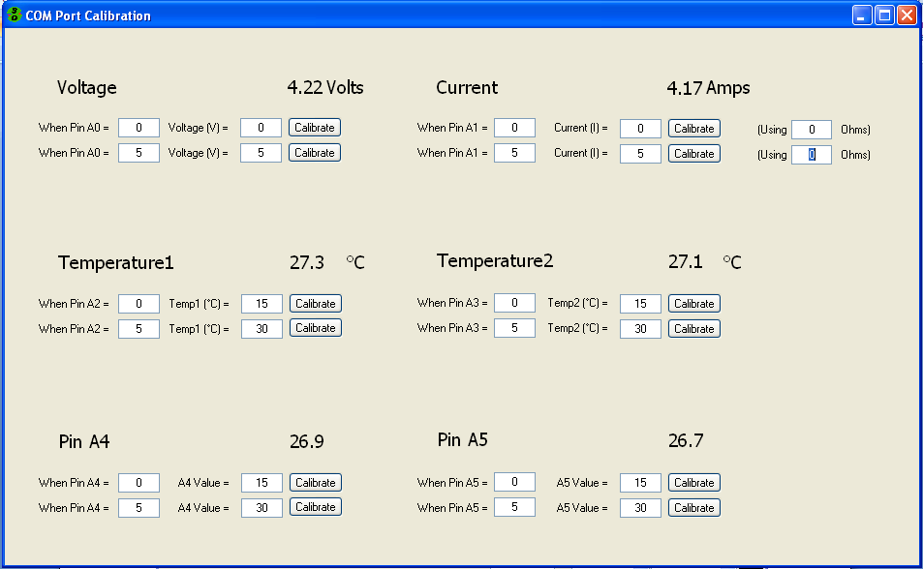The COM Port Calibration window is where calibration values for each of the analog voltage data streams being transmitted to SimpleDyno from the Arduino are entered. SimpleDyno uses linear calibration for all analog inputs on Pins A0 to A5. Two points are needed to define a line, typically a low point and a high point. Each parameter (Voltage, Current, etc.) requires two sets of entries. These entries are presented as statements to help clarify the calibration process. For example, for the Voltage parameter calibration entries for two statements are required. The first is “When the voltage at Pin A0 is 0, the actual voltage of the battery is 0V”. The second statement, using the values measured earlier is “When the voltage at Pin A0 is 4.22, the actual voltage of the battery is 8.29V”. When these values are entered SimpleDyno creates a calibration curve displays the correct voltage on the COM Port Calibration window and also, if this window is closed, on the Label created earlier.

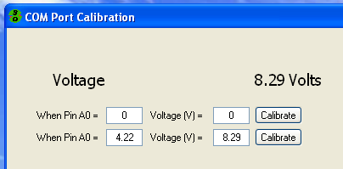

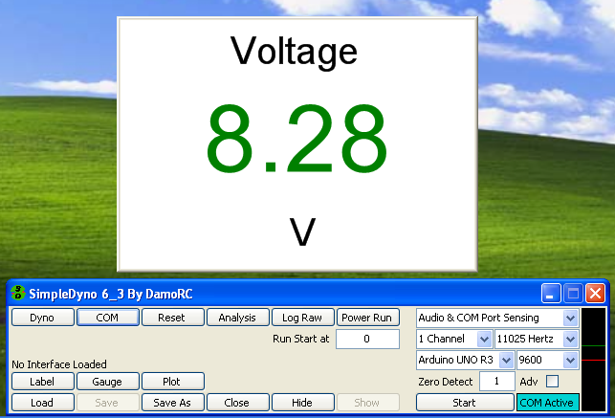

**Note**: Because the voltage calibration curve originally stated that “When Pin A0 equals 5, Voltage = 5V”, this essentially made Pin A0 a voltmeter so the original value of 4.22V could be used for calibration. SimpleDyno also provides a means to complete the calibration entries without needing to measure the voltage at the relevant Pin. Because the Arduino is constantly measuring the voltages at the Analog Pins and transmitting the data to SimpleDyno there are slight fluctuations in the Pin measurements making it difficult to decide what value to enter for “When Pin Ax . This is made easier by using the Calibrate buttons associated with each statement. In this example the actual battery voltage is 8.29V. Enter this into the second part of the statement “Voltage (V) = “. Then click the Calibrate button. SimpleDyno will record the actual voltage at Pin A0 for one second and then place the average of all the values recorded into the “When Pin A0 = “ field.

Calibration of the other parameters (Current, Temp1 and Temp2) is performed in the same way.

**Additional Notes on Current Calibration**

SimpleDyno offers an additional functionality for calibrating current measurements. When using a current sensor with specified measurement ratings (for example 10 Amps produces a 3 V output) then simply enter the specified values into the calibration. However, if the current sensor needs to be calibrated experimentally by applying a voltage across a resistance, the Using X Ohms functionality on the COM Port Calibration window can be used. First, connect and calibrate the Voltage of the power source to be applied across the resistive load. Then enter the accurate resistance of the test load into the Using … Ohms field. Connect the output of the current sensor to Pin A1 (Current). Connect the battery across the resistive load and click Calibrate. SimpleDyno will monitor the signal at Pin A1 for 1 second. It also monitors the battery voltage (Pin A0) at the same time. Once the calibration fields have updated, SimpleDyno uses Ohms law to calculate the actual current measured by the sensor. This feature was introduced because typically, connecting a battery across a resistive load for this calibration causes the voltage across the battery to decrease. Measuring the voltage accurately during the current sensor calibration will produce more accurate calibration values.

**Microcontroller Transmission String for use with SimpleDyno**

To use a microcontroller other than an Arduino for use with SimpleDyno it must be capable of serial communications with the computer over a COM port. For each transaction where the microcontroller sends data to the COM port (which will be received by SimpleDyno) the message string should contain eleven (11) comma separated values which are:

1. Session time (length of time controller has been running) in microseconds
2. The recorded session time for an interrupt triggered at the RPM 1 pin
3. The recorded time between the current and the last interrupt triggered at the RPM1 pin
4. The recorded session time for an interrupt triggered at the RPM 2 pin
5. The recorded time between the current and the last interrupt triggered at the RPM2 pin
6. 10 bit result for Analog pin measuring Voltage
7. 10 bit result for Analog pin measuring Current
8. 10 bit result for Analog pin measuring Temperature1
9. 10 bit result for Analog pin measuring Temperature2
10. 10 bit result for Analog pin measuring a fifth analog pin (equivalent to Pin A4)
11. 10 bit result for Analog pin measuring a sixth analog pin (equivalent to Pin A5)

It is not necessary to measure all the parameters to create the 11 pieces of information and it is not necessary to use analog inputs for the parameters (6) to (11). However, the string sent to SimpleDyno must contain 11 pieces of data and if values are transmitted for parameters (6) to (11) they will be scaled for 5V at 10 bit resolution by SimpleDyno.

**Final Notes on using Arduino**

Using the Arduino for additional data acquisition has been a significant enhancement to SimpleDyno’s capabilities. The advantages are obvious. The main disadvantages are that the electronics are more complicated. For example, the electronics required to accurately measure RPM1 and RPM2 (not covered here) are considerably more complicated than the simple Audio approach with headphones and magnet. That is why a hybrid option is offered via the Audio & COM Port Sensing mode. This is the simplest hardware setup to use with a microcontroller. However, the clock resolution of the Arduino is better than the highest sample rate option of 44,100 Hz for Audio signal processing and therefore more accurate RPM1 and RPM2 measurements are possible using the Arduino.

**Document History**

1. Version 1.0 – First version of instructions distributed with 6.3
2. Version 2.0 – Updated instructions for distribution with 6.4 including
   1. Description of newly added corrections button with details on the coast down function
   2. Update of curve fitting section to describe MA Smooth function and new feature whereby the torque and power curves are overlaid on the fit to aid in selecting a curve fit model or smoothing window.
3. Version 3.0 – Updated instructions for version 6.5 including
   1. Description of the new gauge formatting options